**Practical No:02**

**OOPs concepts in Java – 2**

1. **Write a program to implement the concepts of Inheritance and Method overriding.**
2. **Single inheritance**

**Code:**

class Person

{

String name,city;

int age;

Person(String n,int a,String c)

{

name=n;

age=a;

city=c;

}

void show()

{

System.out.println("Name: "+name);

System.out.println("Age: "+age);

System.out.println("City: "+city);

}

}

class Student extends Person

{

String classes ;

Student(String n,int a,String c,String cl)

{

super(n,a,c);

classes=cl;

}

void show()

{

super.show();

System.out.println("Class: "+classes);

System.out.println(" ");

}

public static void main(String[] args)

{

Student s1=new Student("Vedika Lalit",20,"Sawantwadi","SY.Bsc.IT");

s1.show();

Student s2=new Student("Divya Sutar",20,"Kudal","SY.Bsc.IT");

s2.show();

Student s3=new Student("Shardul Kudav",20,"Vengurla","SY.Bsc.IT");

s3.show();

}

}

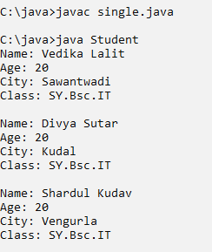**Output:**

1. **Multilevel Inheritance**

**Code:**

class Vehicle

{

String company;

Vehicle(String c)

{

company=c;

}

void show()

{

System.out.println("Company: "+company);

}

}

class Car extends Vehicle

{

String model;

Car(String c,String m)

{

super(c);

model=m;

}

@Override

void show()

{

super.show();

System.out.println("Model: "+model);

}

}

class E_Car extends Car

{

String battery;

E_Car(String c,String m,String b)

{

super(c,m);

battery=b;

}

@Override

void show()

{

super.show();

System.out.println("Battery: "+battery);

System.out.println(" ");

}

public static void main(String[] args)

{

E_Car e=new E_Car("Mahindra","Thar","75Ah");

e.show();

E_Car e1=new E_Car("Tata","Nano","70Ah");

e1.show();

E_Car e2=new E_Car("Suzuki","Swift","75Ah");

e2.show();

}

}

**Output:**

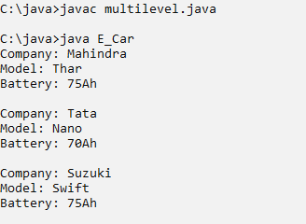

1. **Write a program to implement the concepts of Abstract classes and methods**

**Code:**

abstract class Employee

{

int eid;

String name;

Employee(int id,String n)

{

eid=id;

name=n;

}

void display()

{

System.out.println("Employee ID: "+eid);

System.out.println("Employee Name: "+name);

}

abstract void Calculate_Salary();

}

class Yearly_salary extends Employee

{

int month_salary,year_salary;

Yearly_salary(int id,String n,int ms)

{

super(id,n);

month_salary=ms;

}

void display()

{

super.display();

System.out.println("Month Salary: "+month_salary);

}

@Override

void Calculate_Salary()

{

year_salary=month_salary*12;

System.out.println("Year Salary: "+year_salary);

}

}

class Hourly_salary extends Employee

{

int hrs,rate=1000,hours_salary;

Hourly_salary(int id,String n,int hs)

{

super(id,n);

hrs=hs;

}

void display()

{

super.display();

System.out.println("Hours: "+hrs);

}

@Override

void Calculate_Salary()

{

hours_salary=hrs*rate;

System.out.println("Hours Salary: "+hours_salary);

}

}

class Main

{

public static void main(String args[])

{

Yearly_salary ys=new Yearly_salary(101,"Vedika Lalit",20000);

ys.display();

ys.Calculate_Salary();

System.out.println(" ");

Hourly_salary hs=new Hourly_salary(101,"Vedika Lalit",3);

hs.display();

hs.Calculate_Salary();

}

}

**Output:**

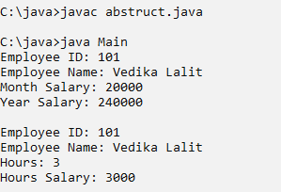

1. **Write a program to implement the concept of interfaces**

**Code:**

interface Transaction

{

public void deposite(float amt);

public void withdraw(float amt);

}

interface Interest

{

public void addInterest(float rate);

}

class Bank implements Transaction,Interest

{

String name;

float balance;

int acc_no;

Bank(String n,float b,int a)

{

name=n;

balance=b;

acc_no=a;

}

public void display()

{

System.out.println("Name: "+name);

System.out.println("Balance: "+balance);

System.out.println("Account No: : "+acc_no);

}

public void deposite(float amt)

{

balance=balance+amt;

System.out.println("Total Balance: "+balance);

}

public void withdraw(float amt)

{

balance=balance-amt;

System.out.println("Total Remaining Balance: "+balance);

}

public void addInterest(float rate)

{

balance=(balance*rate/100);

System.out.println("After adding interest: "+balance);

}

public static void main(String[] args)

{

Bank b=new Bank("Vedika Lalit",5000,10072005);

b.display();

b.deposite(10000);

b.withdraw(200);

b.addInterest(10);

}

}

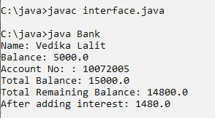**Output:**